Part A: API Design

Proposed Endpoints
The following four endpoints are proposed for the Limkokwing Library API:
Endpoint | HTTP Method | Purpose
/books | GET | Search for books by title, author, or category
/borrow | POST | Allow a user to borrow an available book
/return | POST | Allow a user to return a borrowed book
/users/{user_id}/fines | GET | Track overdue books and calculate fines for a specific user

Detailed Endpoint Descriptions

1. GET /books
Purpose: This endpoint allows library staff and users to search for books using filters such as title, author, or category. It returns a list of books matching the search criteria.
Inputs (Query Parameters):
- title (optional, string) – partial or full book title
- author (optional, string) – partial or full author name
- category (optional, string) – book category (e.g., Programming, Data, Web)
Output Example (JSON):
json
[
{
"id": 1,
"title": "Python Programming",
"author": "John Smith",
"category": "Programming",
"available": true
}
]

2. POST /borrow
Purpose: This endpoint allows a user to borrow a book. The system checks if the book is available, marks it as borrowed, and sets a due date (14 days from borrowing date).
Inputs (JSON Body):
- user_id (string, required) – unique identifier for the user
- book_id (integer, required) – unique identifier for the book
Output Example (JSON):
json
{
"message": "Book borrowed successfully",
"due_date": "2026-05-20T10:00:00"
}

3. POST /return
Purpose: This endpoint allows a user to return a borrowed book. The system calculates any overdue fines (50 cents per day after due date) and updates the book's availability.
Inputs (JSON Body):
- user_id (string, required)
- book_id (integer, required)
Output Example (JSON):
json
{
"message": "Book returned",
"fine": 1.50
}

4. GET /users/{user_id}/fines
Purpose: This endpoint retrieves all overdue books and the total accumulated fines for a specific user.
Inputs (Path Parameter):
- user_id (string, required)
Output Example (JSON):
json
{
"user_id": "U001",
"total_fine": 5.50,
"overdue_books": [
{
"book_id": 2,
"days_overdue": 11
}
]
}

Interaction Diagram (Hand-Drawn Description)
The diagram below (to be drawn manually on paper) shows how the client, API, and server interact:
Flow Description:
- The Client (web browser or mobile app) sends an HTTP request to the API (FastAPI server). For example, a user searches for books by author.
- The API receives the request and communicates with the Server/Database to fetch or update data.
- The Server processes the request (e.g., queries the database for books matching the author name) and returns the result to the API.
- The API formats the data as JSON and sends an HTTP response back to the Client.
For multiple users accessing at the same time:
- User A and User B send simultaneous requests (e.g., both trying to borrow the same book).
- The API uses asynchronous programming (async/await) to handle both requests concurrently without blocking.
- The server processes each request independently and returns responses in parallel.
CLIENT (Browser/App)
│
│ 1. GET /books?author=John
▼
API (FastAPI)
│
│ 2. Query database
▼
SERVER/DATABASE
│
│ 3. Return results
▼
API ──► 4. JSON response ──► CLIENT

Implementation Summary
A complete Python script was written using FastAPI to simulate at least two of the proposed endpoints. The implementation includes:
- Asynchronous programming using async def and await to handle multiple users borrowing and returning books simultaneously. A special endpoint /simulate_concurrent demonstrates concurrent borrowing with asyncio.gather().
- Type annotations throughout the code, including List, Optional, Dict, and custom Pydantic models like Book, BorrowRequest, and FineResponse.
- Mock database using Python dictionaries to store books and borrow records.
- Automated fine calculation based on days overdue.

How to Run the Code
- Install dependencies: pip install fastapi uvicorn pydantic
- Run the script: python library_api.py
- Open browser at http://127.0.0.1:8000/docs to test endpoints via Swagger UI.

Screenshots
(Attach screenshots here showing:)
- Terminal with server running
- Swagger UI interface
- Successful response from GET /books
- Successful response from POST /borrow

How APIs Improve Efficiency in Library Services
APIs significantly improve efficiency in Limkokwing library services by automating routine tasks that were previously done manually. Instead of library staff searching through physical shelves or paper records, an API allows instant digital search by title, author, or category, returning results in milliseconds. The borrowing and return processes become self-service, reducing queues at the circulation desk. Staff with limited technical knowledge can use simple web forms that call the API without needing to understand complex database queries. Additionally, APIs enable real-time fine calculation and overdue tracking, eliminating manual calculation errors. The ability to handle multiple users concurrently ensures that no single user slows down the system for others, making the library more accessible and responsive to student needs.

Alignment with Sustainable Development Goals (SDG)
This assignment aligns with SDG 4: Quality Education. A well-organized digital library system ensures that students and researchers can quickly access learning resources, borrow books efficiently, and return them on time. By reducing administrative barriers, the API promotes lifelong learning opportunities for all. Tracking overdue books and fines also encourages responsible use of shared educational materials, maximizing their availability for the entire academic community. Ultimately, technology-enabled libraries contribute to inclusive and equitable quality education.

Challenges Faced
Three main challenges were encountered during design and coding. First, handling multiple simultaneous requests required understanding asynchronous programming. Without async and await, a slow database call could block all other users. This was solved using asyncio.gather() to run tasks concurrently. Second, structuring JSON responses required careful decisions about which fields to include. Too much data made responses slow, while too little made them unhelpful. The final design balanced simplicity with completeness. Third, fine calculation logic needed precise datetime handling to ensure fines only applied after the due date and accumulated correctly per day.

Suggested Improvement for Library Expansion
If the library expands its services, I would add a reservation system where users can place holds on books that are currently borrowed. When a book is returned, the next user in the waiting list would be notified automatically via email or SMS. This feature would require adding a waiting list table, a background task to process returns, and an email notification service. This improvement would further enhance resource sharing and reduce frustration for students waiting for popular books.

Repository Information
A GitHub repository was created for this assignment with the following details:
- Repository Name: limkokwing-library-api
- Visibility: Public (collaborator access granted to lecturer)
- Repository URL: (insert your GitHub URL here)

Repository Contents
File | Purpose
library_api.py | Main Python script with all API endpoints
requirements.txt | List of Python dependencies (FastAPI, Uvicorn, Pydantic)
README.md | Project title, description, installation instructions, and usage guide
.gitignore | Excludes __pycache__/, *.pyc, .env, and other unnecessary files

Lecturer as Collaborator
The lecturer (Amandus Benjamin Coker) has been added as a collaborator to the GitHub repository using the email: amandus.bocker@limkokwing.edu.sl

How to Access
bash
git clone https://github.com/YOUR_USERNAME/limkokwing-library-api.git
cd limkokwing-library-api
pip install -r requirements.txt
python library_api.py

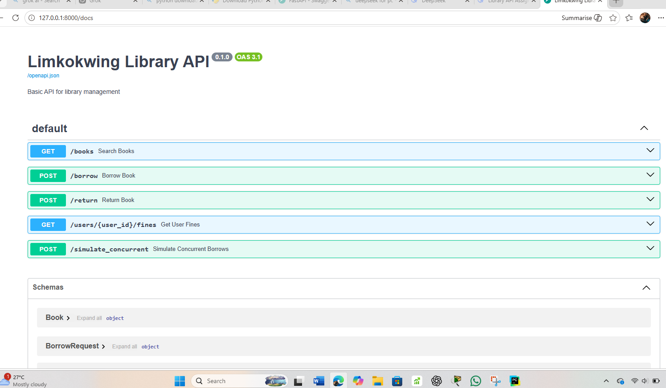

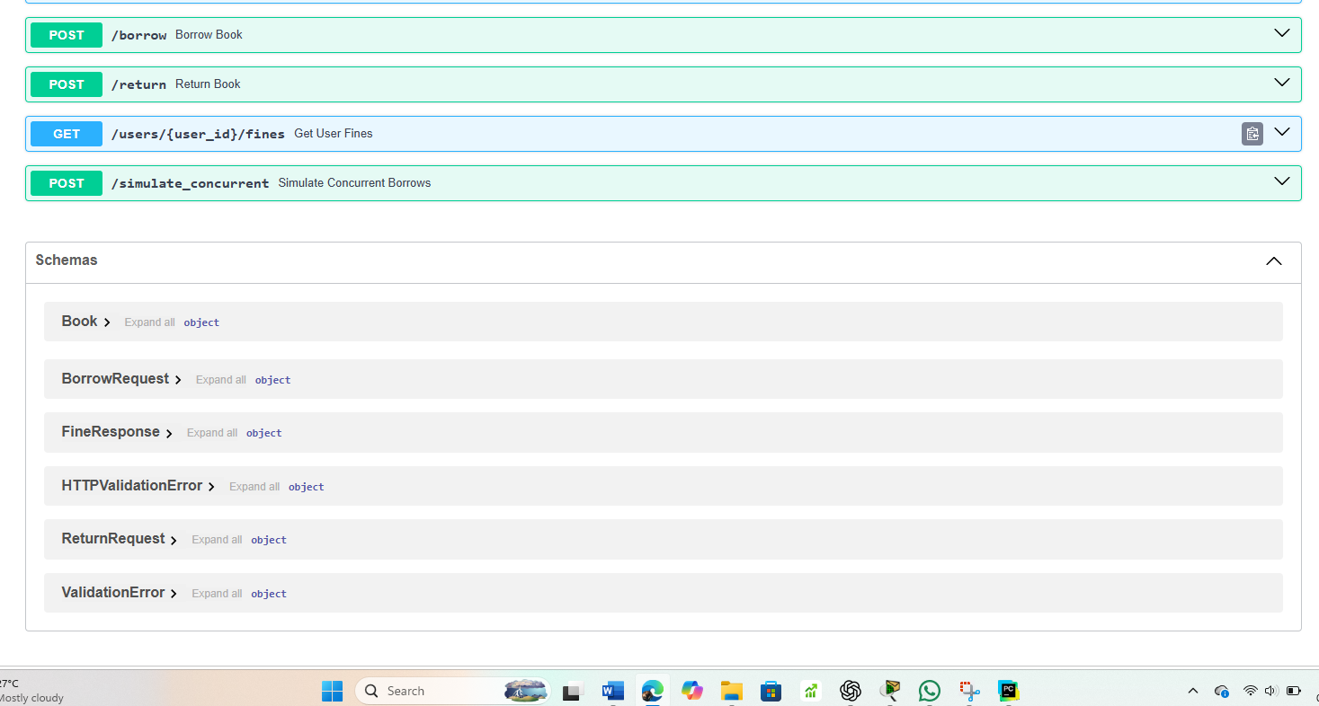

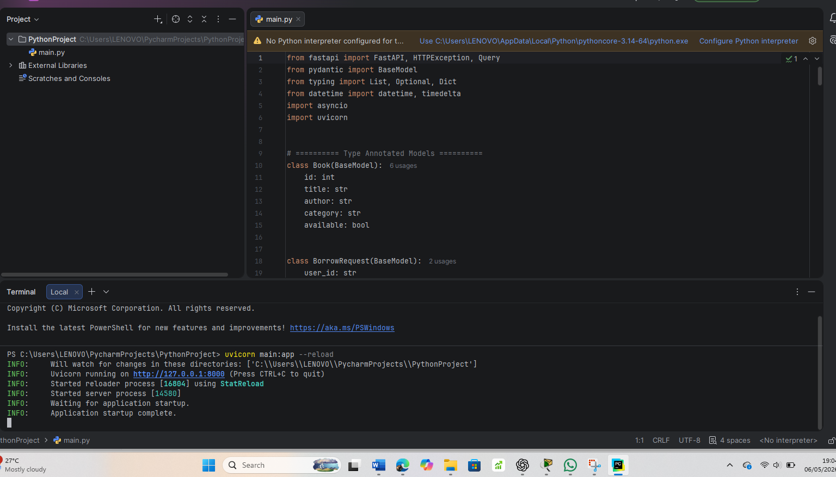

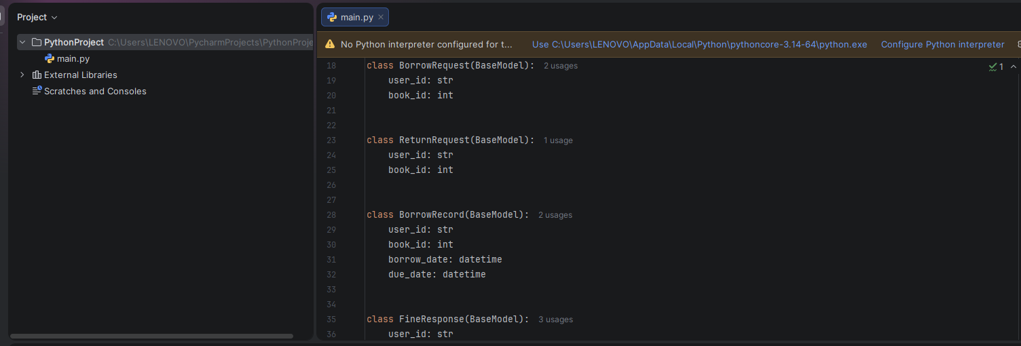

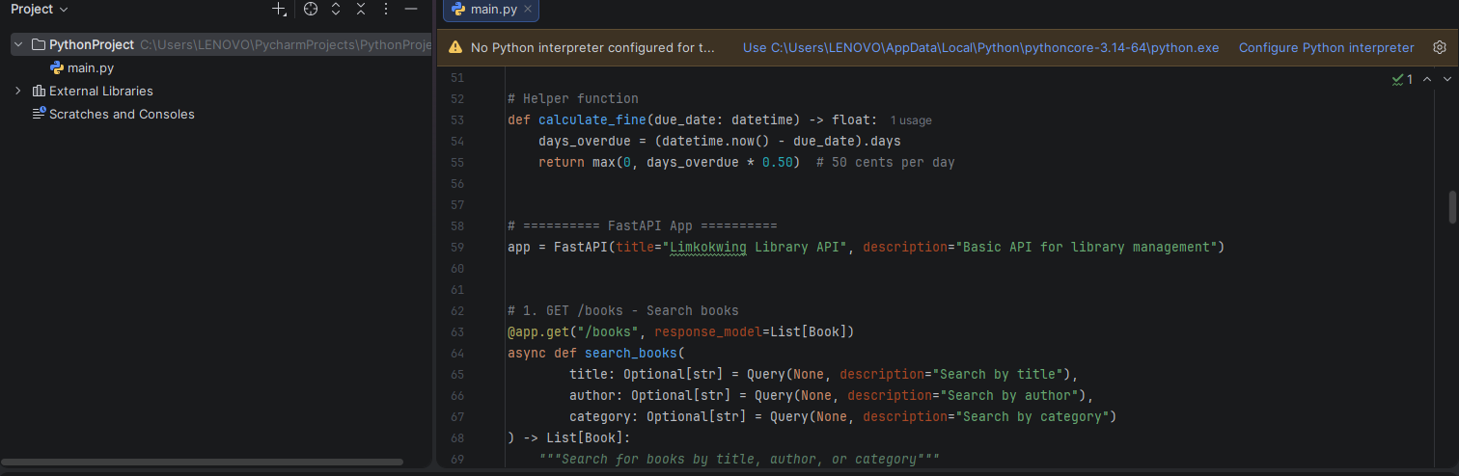

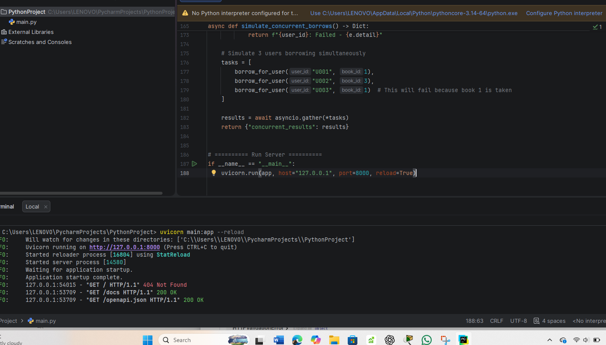

Conclusion
This assignment successfully demonstrates a basic API structure for the Limkokwing library system. The design includes four well-defined endpoints, an asynchronous implementation using FastAPI, and full type annotations. The reflection links the project to SDG 4 (Quality Education) and identifies practical challenges and improvements. The GitHub repository ensures open-source accessibility and collaboration with the course examiner.

References
- FastAPI Documentation. (2026). FastAPI. Retrieved from https://fastapi.tiangolo.com
- United Nations. (2026). Sustainable Development Goal 4: Quality Education. Retrieved from https://sdgs.un.org/goals/goal4

